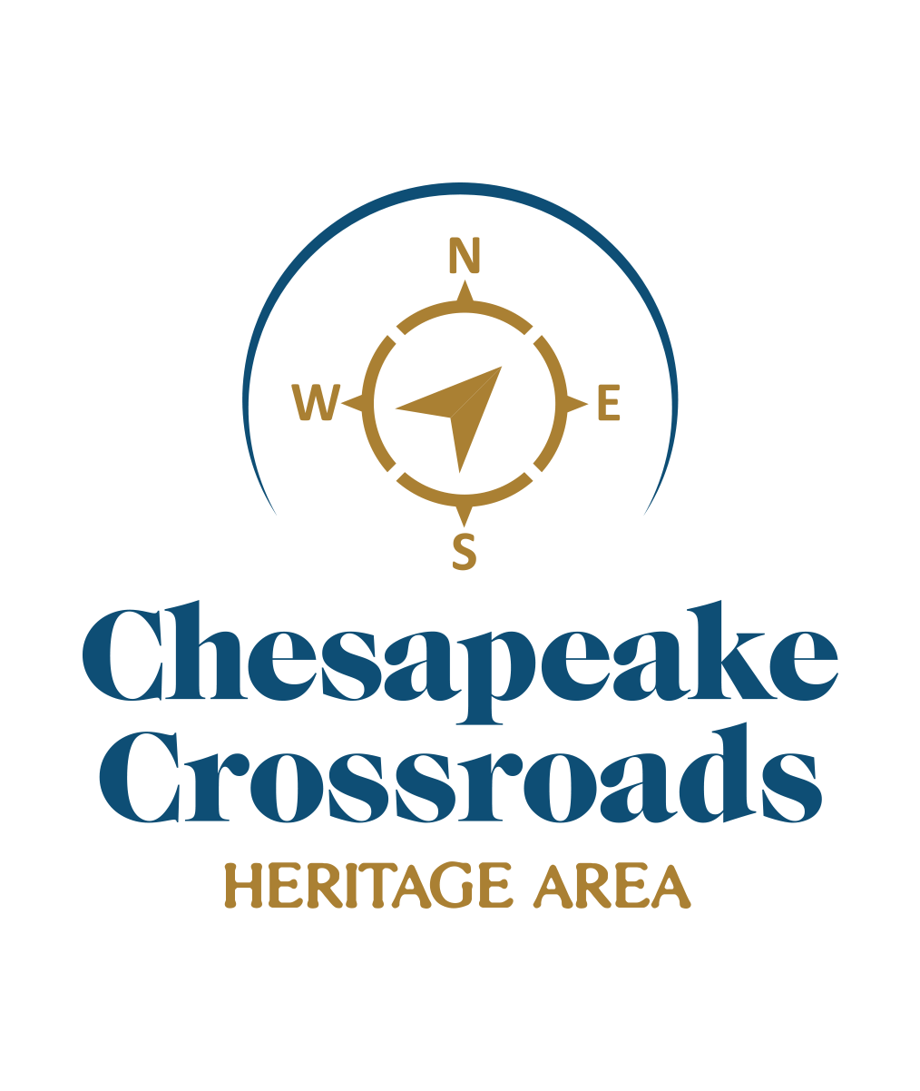
CHESAPEAKE CROSSROADS HERITAGE AREA
Call for Nominations for Nineteenth Annual
Heritage Awards

Chesapeake Crossroads Heritage Awards honor individuals and organizations that make significant contributions to our regional legacy through interpretation, education, preservation, conservation, promotion, research, and/or support. Nominations should be submitted via e-mail with supporting documentation by Friday, October 7, 2022. To review a list of past honorees, please visit our website.
Heritage Award Categories:
- HERITAGE TOURISM PRODUCT AWARD - Recognizing an outstanding heritage tourism product created in the past year. Eligible products include exhibits, events, programs, self-guided or guided tours, audiotours, videos/CDs/podcasts, interpretive brochures, publications and websites. Samples (or images if appropriate) of the nominated product must accompany the nomination.
- HERITAGE VOLUNTEER AWARD - Recognizing an outstanding volunteer who has made a significant difference to the growth, sustainability, programming, or other essential element of a non-profit or for-profit heritage organization. Only one person from each heritage site/organization may be nominated.
- HERITAGE PARTNERSHIP AWARD - Recognizing an outstanding regional partnership in heritage interpretation, preservation, stewardship, and/or education.
- HERITAGE SPONSOR OF THE YEAR - Recognizing a regional business or organization for outstanding sponsorship, patronage or other role in funding one or more heritage-related organizations, events, or products in the past year. Supporting documentation for this category should include materials, publications, etc., resulting from the sponsorship.
- HERITAGE PROFESSIONAL OF THE YEAR - Recognizing an author, archaeologist, architect, artist, exhibits/publications designer, historian, natural resource professional, preservationist, professional staff person, or researcher, for significant professional contributions to heritage interpretation, stewardship, and/or education in the past year. Supporting documentation for this category should include a curriculum vitae/resumé, and an appropriate work sample.
- HERITAGE INTERPRETER OF THE YEAR - Recognizing a heritage interpreter—docent, educator, tour guide, volunteer—in a non-profit or for-profit heritage organization, who provides outstanding factual, and educational information to the public. Only one person from each heritage site/organization may be nominated.
- NEW OUTDOORS INITIATIVE AWARD – Recognizing a new outdoors initiative that enhances the heritage experience of visitors. Appropriate supporting documentation should be included.
- LEGACY AWARD - Recognizing an individual or group who continues or preserves a traditional craft or livelihood—a craftsperson, waterman, farmer, quilter, musician, boat builder, etc.
- PUBLIC/PRIVATE INITIATIVE AWARD - Recognizing an outstanding initiative undertaken through a partnership of public and private businesses or organizations to promote local heritage—i.e., historical signage or markers, photographic displays, brochures, tours, etc. Samples (or images if appropriate) of the nominated product must accompany the nomination.
- STEWARDSHIP AWARD - Recognizing an individual, family, organization, event, or business in the heritage area that demonstrates outstanding leadership in a stewardship capacity. Appropriate supporting documentation should be included.
- HERITAGE LEADERSHIP AWARD - Recognizing an individual for significant and long-lasting contributions to the community by interpreting, preserving, promoting, researching, and/or supporting local history and heritage. Supporting documentation should establish the nominee’s standing in the community.

Chesapeake Crossroads
Heritage Awards Nomination
-Cover Sheet-
Deadline: October 7, 2022

Nominee:
Category:
Nominee’s Organization (if applicable):
Address: City: Zip:
Phone: _Email: Website:

Person Nominating: Business/Organization:_
Address: City: Zip:
Phone: Email:

Please attach a brief statement of why you feel your nominee should be recognized, with supporting documentation as appropriate. Scan this cover sheet with attachments and send via e-mail to heritage_area@aacounty.org. Please put “Heritage Awards Nomination” in the subject line. Questions? Please call Carol at 410-627-6018. Thank you!

