Four Rivers Heritage
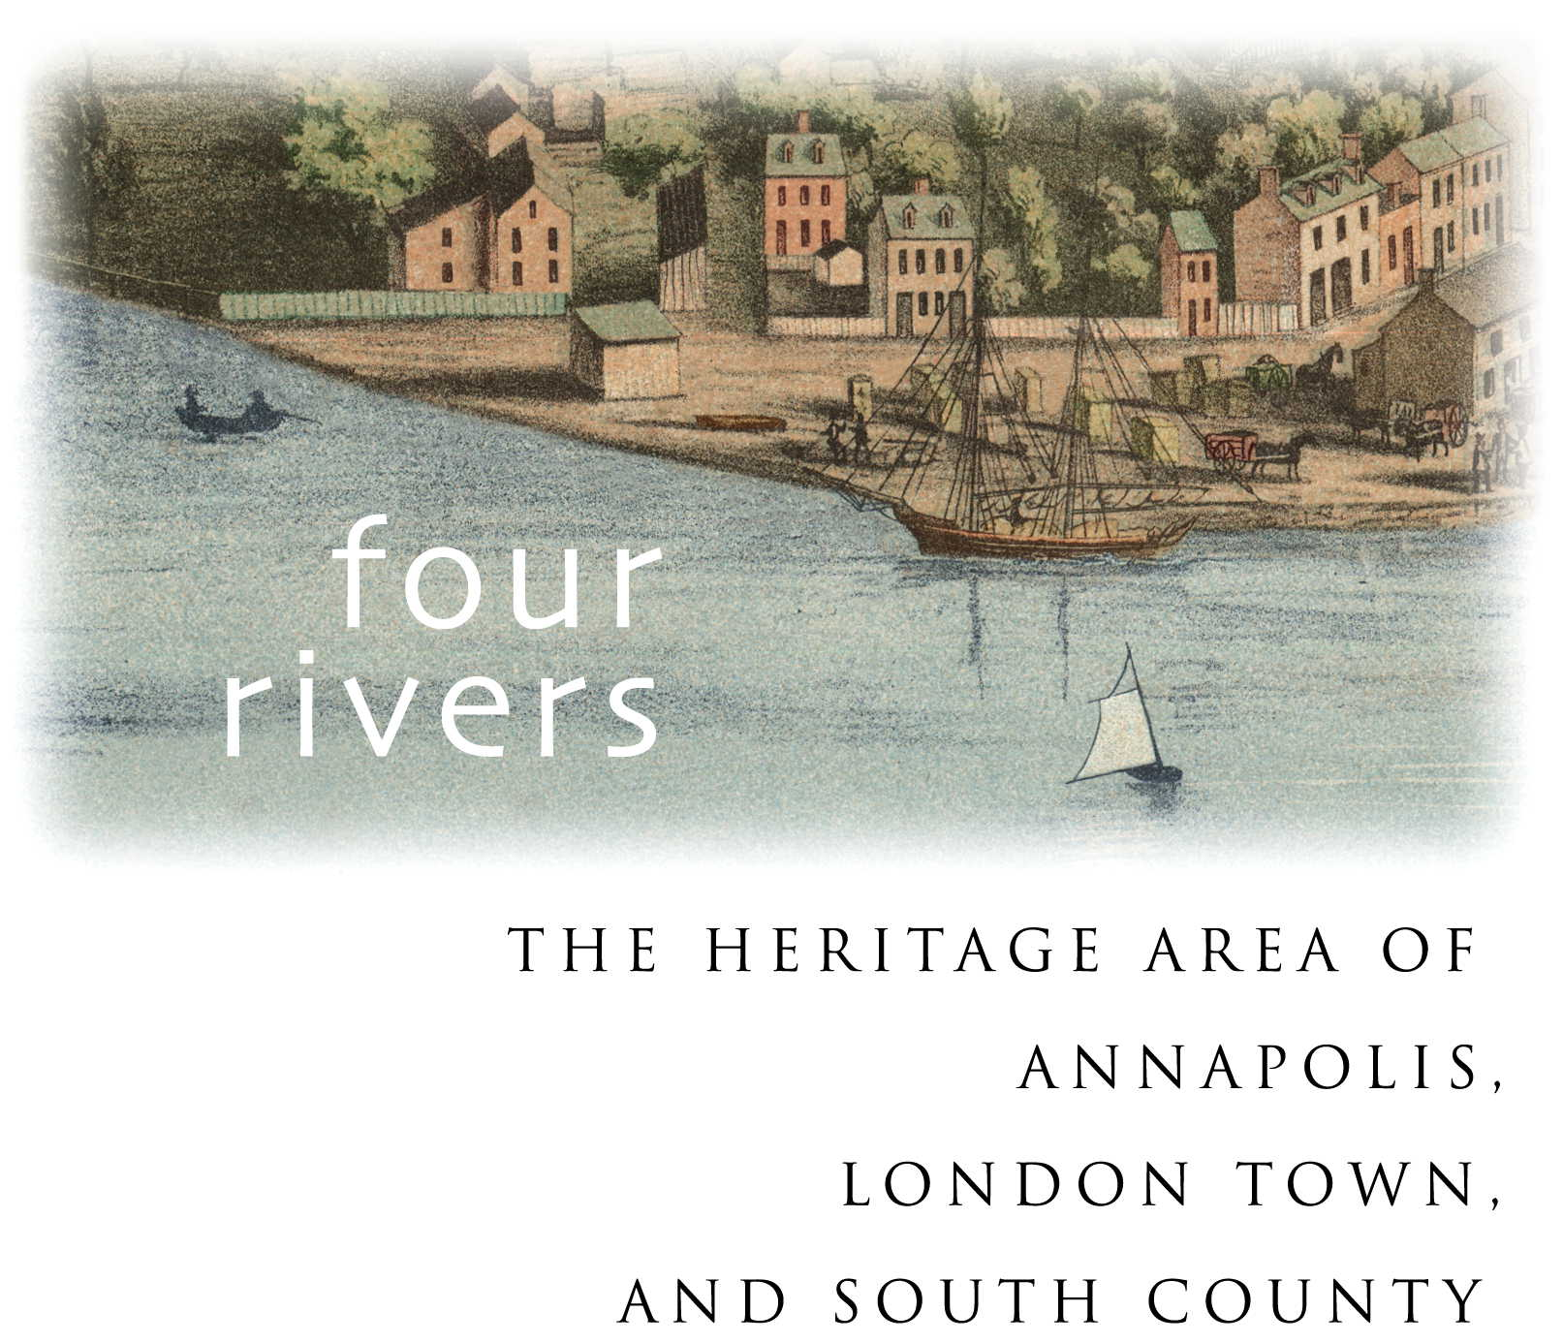
Award Winners 2004-2020

Four Rivers Heritage Awards honor individuals and organizations that make significant contributions to our historical legacy through interpretation, education, preservation, conservation, promotion, research, and/or support.

2020
Heritage Tourism Product Award – experience - Wilma Lee Tour, Annapolis Maritime Museum & Park,
Heritage Tourism Product Award – book - The Maryland State House: 250 Years of History, by Mimi Scrivener Calver, Author and Medford Canby, Photographer
Heritage Volunteer Award - Cathy Oliver, Galesville Heritage Society
Heritage Volunteer Award - Catherine Schmidt, Historic Annapolis
Legacy Award - “Cooking on The Chesapeake” Culinary Programs, Galesville Community Center Organization and Vincent O. Leggett
Heritage Partnership of the Year Award - “A Celebration of Harriet Tubman and Frederick Douglass,” Maryland State Archives, Maryland Commission on African American History and Culture, National Underground Railroad Network to Freedom (National Park Service), Maryland Department of Commerce – Office of Tourism, and Friends of the Maryland State Archives
Heritage Interpreter of the Year Award - Nannetta Hall, Historic Annapolis
Public/Private Initiative Award – “Anne Arundel County Lynching Memorial,” Connecting the Dots, Maryland Lynching Memorial Project, Equal Justice Initiative, Anne Arundel County, City of Annapolis, Co-chairs Monica Lindsey and Jennifer Haber, Emma Buchman, Lee Zanger, Jane Zanger, Renee Cantori, and Will Schwarz
Heritage Professional of the Year Award - Carrie Kiewitt, Historic Annapolis
Heritage Leadership Award - Mimi Scrivener Calver
2019
Heritage Tourism Collaboration of the Year Award - “African-American Voices, Memories, and Places: A Four Rivers Heritage Trail,” Lost Towns Project, Anne Arundel County’s Cultural Resources staff, and partners

Heritage Professional of the Year Award - Rachel Lovett, Hammond-Harwood House

Heritage Volunteers of the Year Award - Craig Biggs and Dennis Krizek, Annapolis Maritime Museum

Heritage Partnership of the Year Award - Chesapeake Music Festival, a partnership between the Smithsonian Environmental Research Center, Arundel Rivers Federation, and many more

Heritage Sponsor of the Year Award - Bay Weekly

Legacy Award - “Model Boat Builders of South County,” Galesville Heritage Society and the Deale Area Historical Society

Stewardship Award - “Tread Lightly: Climate Change & You,” Annapolis Green

Public/Private Initiative of the Year Award - “Smith Price: The Homecoming – Reparation, Reunion and Reburial”

Patricia Barland Leadership Award - Dale Glenwood Green

2018
Heritage Tourism Collaboration of the Year Award - Anne Arundel County Commemoration of the Year of Frederick Douglass

Heritage Professional of the Year Award - Caitlin Swaim, Annapolis Maritime Museum

Heritage Volunteer of the Year Award - Anthony Smoot

Heritage Interpreter of the Year Award - Bruce Weidele, Galesville Heritage Society

Heritage Partnership of the Year Award - Southern High School Veterans Oral History Project, with Southern High School under the direction of teacher Jennifer Davidson, and Maryland Humanities

Heritage Sponsorship of the Year Award - Kunta Kinte-Alex Haley Foundation for “Bates, Center of Excellence: Memories of Bates Teachers, A Legacy” Documentary Project, with Patsy Baker Blackshear, Anthony A. Smoot, Vivian Gist Spencer, Sharyn Martin, Carroll Hynson, Lyndra Marshall (Nee Pratt), Christopher Haley, and Valerie Yancey

Public/Private Partnership of the Year Award - “Build-a-Boat” and Summer Maritime programs for youth, Box of Rain and the Annapolis Maritime Museum, and Chesapeake Light Craft

Patricia Barland Leadership Award - Mianna Jopp

2017
Heritage Tourism Product Award - “Twentieth-Century Beach Resorts,” Anne Arundel County Department of Planning and Zoning’s Cultural Resource Division, with Anne Arundel County Department of Recreation and Parks, Anne Arundel County Trust for Preservation, and Maryland Heritage Areas Authority

Heritage Professional of the Year - Lisa Robbins, Historic Annapolis

Heritage Volunteer of the Year Award - Roger Marshall

Heritage Interpreter of the Year Award - Pat Turlington, Watermark

Heritage Partnership Award - Ruth Starr Rose in Annapolis Organizing Committee, Elizabeth Myers Mitchell Gallery of St. John’s College, with Anne Arundel County Public Schools, Historic Annapolis, the City of Annapolis, the Maryland Commission on African American History and Culture, the Northern Arundel Cultural Preservation Society, and Ramocille Johnson with the Extensions of Faith Praise Choir

Stewardship Award - John Gudas, Annapolis Maritime Museum

Patricia Barland Leadership Award - Dr. Jean B. Russo

Certificate of Appreciation - Nielsen Family

2016
Heritage Tourism Product Award - “Historian Annapolis” Campaign, Visit Annapolis and Anne Arundel County

Heritage Professional of the Year Award - Valentino Owens of Valeu Photography

Volunteer of the Year Award - Eileen Leahy of the Charles Carroll House of Annapolis

Heritage Interpreter of the Year Award - Judith Jones of the Hammond-Harwood House

Heritage Partnership Award - Historic Annapolis and Annapolis Tours by Watermark

The Stewardship Award - Weather it Together Initiative by Mayor Pantelides and the Annapolis City Council

Public/Private Initiative Award - Annapolis Art in Public Places Commission

Heritage Sponsor of the Year Award - Judi Hermann of Hermann Advertising

Heritage Leadership Award - Dorothy Whitman of the Galesville Heritage Society

The Patricia Barland Leadership Award - Ted and Betty Mack

2015
Heritage Tourism Product Award - Interpretive Exhibits in the Senate Committee Room, Stairwell Room, and Old Senate Chamber of the Maryland State House

Heritage Volunteer of the Year - Alma Cropper of the Wiley H. Bates Legacy Center

Heritage Professional of the Year - Elaine Rice Bachmann of the Maryland State House

The Stewardship Award - Education Center and Oyster Education Program at the Annapolis Maritime Museum

Heritage Partnership Award “Field of Dreams - Home Grown History” Project, Galesville Community Center

Heritage Sponsor of the Year - Ray and Stacy Greenstreet of Greenstreet Gardens

Heritage Leadership Award - Robert L. Worden

Heritage Leadership Award - Lyndra Marshall

2014
Heritage Tourism Product Award - Historic London Town and Gardens’ “Garden Guide”

Heritage Interpreter of the Year - Elinor Thompson

Heritage Professional of the Year - Heather Skipper of Watermark

Stewardship Award - Lisa Barge, Anne Arundel Economic Development

Heritage Partnership Award - Kunta Kinte Children’s Festival of 2014. Honorees - Chesapeake Children’s Museum, City of Annapolis, and performer Kwame Ansah-Brew

Heritage Leadership Award - Jean Jackson of the Kunta Kinte Heritage Festival in Annapolis

Certificates of Appreciation - Towne Transport and Visit Annapolis (Annapolis and Anne Arundel County Conference and Visitors Bureau)

2013
Heritage Tourism Product Award - “Freedom Bound - Runaways of the Chesapeake,” Historic Annapolis and Partners

Public/Private Initiative Award - Civil Rights “Foot Soldiers” Memorial, Dr. Martin Luther King Jr. Committee, Anne Arundel County, the City of Annapolis and Capital Gazette Communications,

New Initiative Award - Advocates for Herring Bay

Heritage Partnership Award - The October 2012 “War of 1812 Commemoration” by the Deale Area Historical Society

Heritage Sponsor of the Year - Dick Franyo

Special Recognition - Chesapeake Eye Care and Laser and Severn Savings Bank

Heritage Interpreter of the Year - Fred Taylor of Annapolis Tours by Watermark

Heritage Professional of the Year - Nathan Powers of Historic London Town and Gardens.

Legacy Award - Art Tuers of the Annapolis Maritime Museum

Heritage Leadership Award - Dr. Edward C. Papenfuse of the Maryland State Archives

2012
Heritage Tourism Product Award - “Discover London Town!” by Historic London Town and Gardens

Public/Private Initiative Award - “Seas, Lakes & Bay - The Naval War of 1812 Bicentennial Walking tour” by the United States Naval Academy and Annapolis Tours by Watermark

New Initiative Award - Energy Audit and Festival Greening programs by Annapolis Green

Heritage Partnership Award - “Our Common Threads” Project by Anne Arundel County Public Schools, Banneker-Douglass Museum, Historic Annapolis, and Historic London Town & Gardens

Heritage Interpreter of the Year - Marcos Salaveria of Historic Annapolis

Heritage Professional of the Year - Terry Poisson of Anne Arundel County Public Schools

Heritage Leadership Award - Jefferson Holland

Heritage Leadership Award - Judith Cabral

2011
Heritage Tourism Product Award - Project Run-A-Way by Historic Annapolis

New Initiative Award - Multi-phase roof-restoration project by the Hammond-Harwood House Association

Heritage Interpreter of the Year Award - Ruth Hazen of the Deale Area Historical Society

Heritage Professional Award - Jane McWilliams

Heritage Leadership Award - Ann Jensen

Heritage Leadership Award - Virginia Clagett

2010
New Initiative Award - Captain Salem Avery Museum’s Heritage Eco-Tour

Heritage Interpreter of the Year - Meg Govan, Watermark

Legacy Award - Clarence “Speedy” Hogarth, Historic Annapolis Foundation

Public/Private Partnership Award - The City of Annapolis Gott’s Court Parking Garden.

Heritage Partnership Award - Historic London Town and Gardens and Anne Arundel County Public Schools

Heritage Partnership Award - “Music To our Ears - The Sounds of the African American Experience at Carr’s and Sparrow’s Beaches,” by the Banneker-Douglass Museum, Anne Arundel County Public Schools, Annapolis High School, and the Blacks of the Chesapeake Foundation

Heritage Professional Award - Genevieve Kaplan, the Education and Public Program Manager, Banneker-Douglass Museum

Heritage Leadership Award - Vincent Leggett, founder and former president of the Blacks of the Chesapeake Foundation

Heritage Leadership Award - Gertrude Makell of Galesville

2009
Heritage Professional - Scotti Preston, Historic Annapolis Foundation Living History performer and educator

Heritage Professional - Dr. John Kille, Lost Towns Project, Londontown Foundation and Anne Arundel County Trust for Preservation

Legacy Award - Dr. Joan M. E. Gaither, Documentary Story Quilter

Legacy Award - Norman Hazard of Galesville, Waterman and Boatbuilder

New Initiative Award - Waypoint Signage and Brochure Showcasing “Best Practices” in Environmental Conservation. Honorees - City of Annapolis Environmental Commission

Heritage Product - Carr’s Beach Historic Music Festival. Honoree - Larry Griffin, Organizer

Heritage Area Certificate of Merit - The Hanover Street Historic Streetscape Reconstruction Project. Honorees - Century Design Engineers, Anchor Construction, Goodwin & Associates, and the Honorable Ellen O. Moyer

Heritage Award - Mavis Daly, Shady Side Rural Heritage Society

Heritage Award - Dr. Al Luckenbach, Anne Arundel County Archaeologist and Founder of the Lost Towns Project

2008
Heritage Tourism Product - “Paddle Through History” Kayak Tour of the Rhode River (partnership with Smithsonian Environmental Research Center) and “Paddle Through History” Kayak Tour of Back Creek and Spa Creek (partnership with Annapolis Maritime Museum). Honorees - Lost Towns Archaeology Project; C. Jane Cox; Jessie Grow; Smithsonian Environmental Research Center; Annapolis Maritime Museum

Heritage Tourism Product - “Seeking Liberty - Annapolis, An Imagined Community” Exhibit at the Banneker-Douglass Museum, in partnership with the Historic Annapolis Foundation and the City of Annapolis. Honorees - Dr. Mark Leone, Guest Curator of the Exhibit and Director of Archaeology in Annapolis; Amelia Harris, Exhibit Designer; Banneker-Douglass Museum; Historic Annapolis Foundation; City of Annapolis Mayor Ellen O. Moyer

Heritage Partnership - Southgate Memorial Fountain Restoration Committee (with special recognition to Alderman Richard Israel, Chair; Mayor Ellen O. Moyer)

Heritage Professional - Matthew Grubbs, Discover Annapolis Tours

Legacy Award - The Spiritual Vibrations of Southern Anne Arundel County

Heritage Award - First Presbyterian Church of Annapolis (Reverend William Hathaway, Pastor)

Heritage Award - June Taft Hall, Shady Side Rural Heritage Society

2007
Heritage Product Award - Annapolis Food & History Tour by Capital City Colonials and Scurlock-Beach Connections photo exhibit by the Highland Beach Historical Commission

Heritage Initiative Award - Thomas Point Shoal Light tours by Annapolis Maritime Museum and the Chesapeake Chapter of the U.S. Lighthouse Society and Lighthouse Tour Manager Tom Stalder

Heritage Partnership Award - Shady Side’s Got History! by the Shady Side Rural Heritage Society and the Shady Side Elementary School

Heritage Partnership Award - Captain John Smith 400 Festival by the Annapolis Maritime Museum

Heritage Professional Award - Donna Hole of the City of Annapolis

Heritage Professional Award - Carol Treiber of the Arts Council of Anne Arundel County.

The Legacy Award - Chesapeake 20 Association

The Heritage Award - Jack Smith and Roberta Cassard of Galesville

2006
Heritage Interpreter of the Year Award - David L. Smith of Capital City Colonials

Heritage Program Award - The Smithsonian Environmental Research Center on the Rhode River for their new Educational Outreach Program

Best New Heritage Initiative - Watermark and the Kunta Kinte-Alex Haley Foundation for the African-American Heritage Tour

Heritage Professional Awards - Patricia Blick for HistoryQuest at Historic Annapolis Foundation’s St. Clair Wright Center

Heritage Professional Awards - Janet Surrett of the Captain Salem Avery House in Shady Side.

Legacy Award - Pam Offer and family

The Heritage Award - Leonard Blackshear, founder of the Kunta Kinte-Alex Haley Foundation

Interpretation Award in Local History - Glenn Campbell and Dr. Jean Russo for HistoryQuest at the St. Clair Wright Center

Interpretation Award in Local History - Banneker-Douglass Museum for Deep Roots, Rising Waters

Interpretation Award in Local History - Ginger Doyel for Annapolis Vignettes and Gone to Market - the Annapolis Market House, 1698-2005

Interpretation Award in Local History - The City of Annapolis for Art in Annapolis and From Declaration to Independence

Interpretation Award in Local History - The Galesville Heritage Society for Heritage Tour, of historic Galesville on the West River

Interpretation Award in Local History - The Chesapeake Children’s Museum for Lead On, Harriet!

2005
Interpreter of the Year - Eleanor Anderson of Historic London Town & Garden

Interpretation Award for Scholarly Publication - Dr. Michael Parker for Presidents Hill - Building an Annapolis Neighborhood, 1664-2005

Interpretation Award in Local History - Jean Siegert Trott for Galesville, Maryland - The Legend…The Legacy

Interpretive Product Award - Annapolis Maritime Museum and Historical Interpretation Committee Chair Dr. William Dudley

Heritage Program Award - The Historic Annapolis Foundation and Chamber Music Annapolis for the Maryland Early Music Festival, with special recognition of Carolyn Surrick and Geoff Giffin

Heritage Event Award - Annapolis Maritime Museum for Maritime Market Days

Best New Heritage Initiative - Annapolis Tours & Watermark Cruises for Bay Lighthouses Tour with living history interpretation by Cliff Long

Best New Heritage Initiative - Galesville Heritage Society for their Living History program

Heritage Professional Award - Dr. Elizabeth Stewart of the Banneker-Douglass Museum

Legacy Award - David and Ginger Hildebrand

Legacy Award - John VanAlstine

The Heritage Award - Marion Warren

2004
Heritage Interpreter of the Year - Nancy Reams with Historic Annapolis Foundation, Historic London Town, the Charles Carroll House, and Hammond Harwood House

First Person Interpretation Award - Janice Hayes Williams of Legacy Promotions and Scotti Preston.

Site Interpretation Award - Hammond Harwood House

Scholarly Publication Award - Dr. Jean Russo and Mark Letzer for The Diary of William Faris - The Daily Life of an Annapolis Silversmith

Local History Award - Lois Nutwell for Ripple in the Wind - Down the Creek and Along the Shore in Deale, Maryland

Interpretive Tour Award - Jack Smith

Children’s Interpretation Award - My Annapolis Adventure - Passport to Discovery“ by the Chesapeake Children’s Museum, Annapolis Department of Transportation, and Ginger Doyel

Educational Interpretation Award - “Seasons of a Chesapeake Bay Waterman - An Activity Guide for Teachers.” By the Captain Salem Avery House, Discovery Village, the Shady Side Elementary School, Annapolis Maritime Museum, waterman John Van Alstine, designer Ruth Ann Thompson, and the Chesapeake Bay Gateways Program

Heritage Event Award - Discovery Village

Heritage Program Award - Annapolis Maritime Museum

Best New Heritage Initiative - Chesapeake Chapter of the U.S. Lighthouse Society, the City of Annapolis, Annapolis Maritime Museum, and Anne Arundel County of the Thomas Point Shoal Light Consortium

Heritage Professional Award - C. Jane Cox of the Anne Arundel County’s Lost Towns Project, the Annapolis Maritime Museum, Anne Arundel County Trust for Historic Preservation, and the Thomas Point Shoal Light

Legacy Award - Russell Steele of Historic London Town & Gardens

The Heritage Award - Paula Fishback of Three Centuries Tours

The Heritage Award - Peg Wallace of the Annapolis Maritime Museum

