We Need Your Stories!
The Lost Towns Project wants to hear your stories about African American history for two grants sponsored by the National Park Service Civil Rights African American Historic Preservation Program and the Maryland Heritage Areas Authority.
Please come to one of the three public meetings listed on the attached flyer to learn more about the project and to schedule your oral history interview, which will take place at a later date. Tell us about the experiences of your family and friends, including your parents, grandparents, and other relatives. There will be stations to scan any related photos, documents, and memorabilia you may want to bring to enhance your stories.
National Park Service Grant
This project involves recreation and leisure throughout Anne Arundel County, where African Americans responded to discrimination and empowered themselves. Below are just some of the Civil Rights era stories we would like to know more about.
African American and segregated beach resorts and communities
Highland, Columbia, Carr’s, Sparrow’s, and Beachwood Park beaches, and segregated beaches such as Bay Ridge, Beverly, Triton, Mayo, Mago Vista and many others.
Swimming pools
Public and private communities and neighborhoods.
Ball fields, basketball courts, and other sporting venues
Wiley H. Bates High School, Naval Academy, Hot Sox Ballfield in Galesville, Drury Ballfield in Lothian, Geno Ballfield in Tracy’s, and other neighborhood locations.
Recreational programs, musical entertainment, and dances
Negro Interurban League, YMCA, USO, Armory, St. John’s College, College Creek Terrace Community Center, private homes, and elsewhere.
Playgrounds in public and private communities and schools,
Rosenwald schools, Stanton Elementary School, College Creek Terrace, and Anne Arundel County Parks and Recreation sites, and elsewhere.
Religious camp meetings and church sponsored events
Singing, concerts, performances, bazaars, and other entertainment.
Local parades and excursions to other areas
Organized events and visits to the Eastern Shore, Baltimore, and other locations.
Social and fraternal activities
Colored Elks Club, “Little joints” such as Randals, Blue Bird, Bob Breen, Blue Dick Bar, Stanley Wrights, Upshop and others.

Maryland Heritage Areas Authority Grant

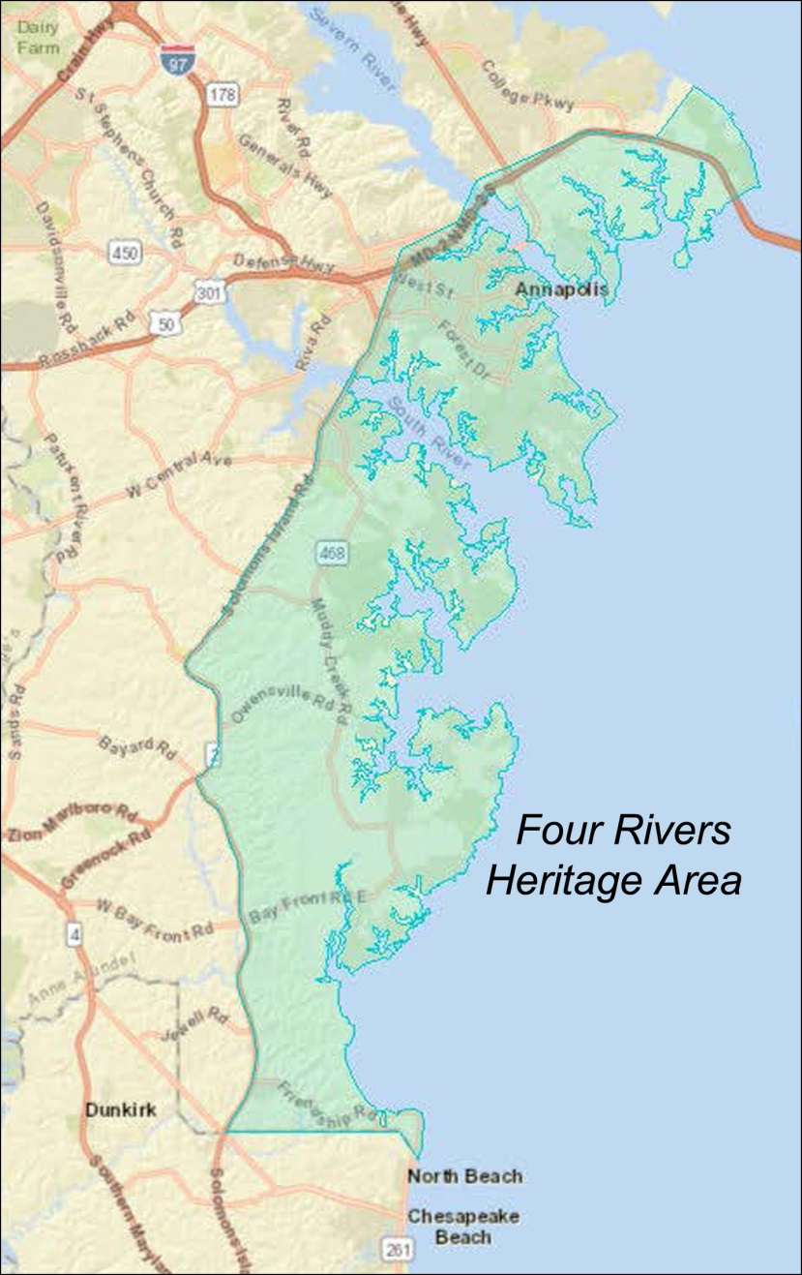
This second grant explores a wide range of African American historic sites within the Four Rivers Heritage Area, beyond Annapolis. We need your stories to extend the African American Heritage Trail in South County. The map shows the boundaries of this study area.

Important African American history is being lost with each passing year; however, you can help us preserve the past before it disappears forever.

Future generations need to know how earlier challenges were met and overcome. Your stories will be used to create two informative, interactive website maps.

